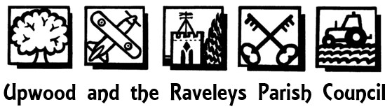

Notice of two vacancies in office of Parish Councillor on Upwood and the Raveleys Parish Council

Notice is hereby given pursuant to section 87(2) of the Local Government Act 1972 that due to the resignation of Councillor Robin Howe there is a vacancy on Upwood & the Raveleys Parish Council.

If, within 14 statutory days after the date of this notice, a request for an election to fill the vacancy due to Councillor Howe is made in writing, to the Proper Officer, Huntingdonshire District Council, Pathfinder House, Huntingdon PE29 3TN by ten electors of the parish an election will be held. If no such notice is given the parish council will fill the vacancy by co-option.

There is also an existing vacancy (due to the death of Councillor Michael Tew). If any member of the parish would like to be considered for co-option for this existing vacancy please contact the Parish Clerk.

Date: 11th April 2023 Signed: Louise Clowery
Parish Clerk/RFO

6 Manor Farm Cottages, Warboys Road, Pidley, Huntingdon, Cambridgeshire. PE28 3DA
Telephone: 07835 939547 E-Mail: parishclerk@upwood.org Website: www.upwood.org

